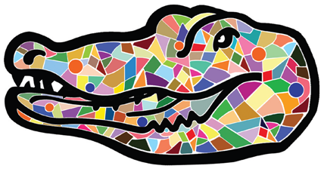

President’s Council on Diversity Meeting

September 22, 2014 10:00 AM HRS Building (Room120)

Conference Call Number 352-273-1774

AGENDA

- Call to Order

- Welcome to new members of the Committee

- Council on Diversity Strategic Goals for 2014-15 – Shari Robinson

- Presidential Search Update

- Sub-committees updates and call for membership

Campus Climate Survey-Jarrod Cruz
Public Relations/Website-Florida Bridgewater-Alford
Conference Planning & Awards-Elnora Mitchell
Data Collection & Reporting
Training & Development-Cynthia Mendoza

- Diversity Symposium – Shari Robinson

- Adjournment

