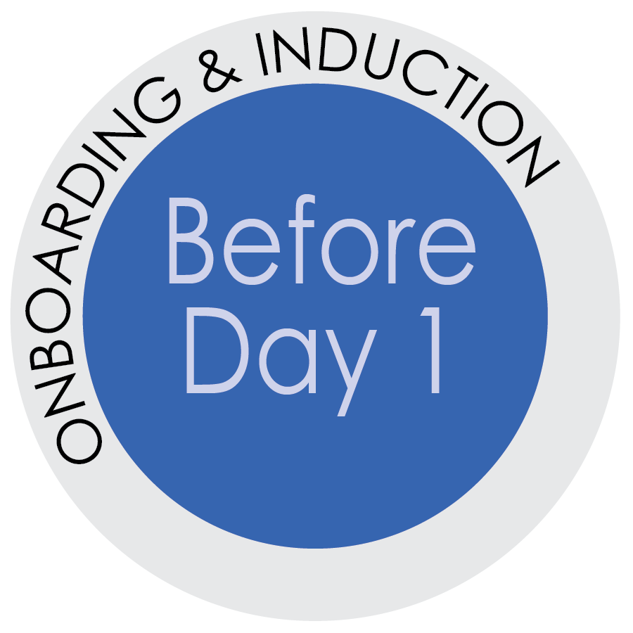
Assigning A Buddy for Your New Hire
Providing a buddy is the first step for building relationships between your new hire and their new peers (as distinguished from member of leadership, such as you).

What is a buddy?
A buddy is someone who partners with the new hire for the first six-months of employment. The buddy responsible for offering advice and guidance regarding the day-to-day aspects of working in the department as well as offering encouragement, feedback and introducing the new hire to the culture of the department. The buddy is like an officially appointed friend.

Why Have a Buddy:
The purpose of assigning your new hire a buddy is to welcome them and reaffirm their decision to be part of the University of Florida. It provides new employees with a reliable, motivated, single point-of-contact for their basic questions regarding their work experience at UF (especially those questions the new hire may not want to ask their new boss, like: Where is the nearest restroom? What do people usually do for lunch? I can’t get the printer to work, what should I do? What, exactly, does casual Friday mean?).

How Does a Direct Supervisor Select a Buddy?
Choose wisely:
- A good buddy is someone who is familiar with the culture, values and
vision of the unit or department.
- A co-worker from the department who will be a positive role model.
- An employee who is familiar with the new hire’s role.
- An employee who has been in his/her role for at least one year.
- A good communicator and strong interpersonal skills.
- As the direct supervisor, you may choose to assign a buddy who does the
same kind of work as the new hire so the buddy can also provide job-specific feedback.
- An employee who has the ability to make time for the new hire and will be accessible to them (don’t pick someone who sits halfway across campus).
- An employee who is trusted and understands that if they become aware of any serious concerns, they will be expected to report the concerns to the appropriate office (more on this topic below).
- An employee who may be interested in a leadership position. Serving as an official new hire buddy is a growth opportunity for the buddy. This may be a way for you to start thinking about who your rising stars are, who has leadership potential, who wants to be a more visible member of the team. You will learn a lot about an existing employee by how they manage serving as a buddy for a new hire. Win-win!

Functions of the Buddy
The buddy will:
- Meet formally once a month for at least 30 minutes in length
- Conduct daily check-ins 5-15 minutes in length to answer questions and
build a relationship
- Serve as a resource for the new employee on expectations,
assignment clarification (if they are familiar with the job-specific
duties), policies, procedures and workplace norms
- Create a comfortable informal environment where the new
employee feels safe bringing up concerns and asking questions
- Be a point of contact for the new employee
- Make introductions to colleagues and customers
- Provide feedback and encouragement for the new hire
IMPORTANT: As the direct supervisor, be sure to regularly check-in with both the new hire and the buddy to ensure that everything is working well—for the new hire and the buddy. It is also important to give the buddy some ability to shape the buddy relationship in such a way that it helps (not overwhelms) the new hire.
Having a buddy or peer feedback partner for the new hire DOES NOT replace the regular check-ins between the new hire and the direct supervisor.
Share the following guidelines with the buddy so they can provide excellent feedback.

Guidelines for Providing Feedback
The purpose of feedback is to help others be successful in their roles. Creating a feedback culture where employees and co-workers regularly provide feedback in all directions leads to a more efficient, trusting and supportive team culture. Induce new employees into your culture of feedback early on by providing him or her with a buddy and/or peer feedback partner.
Direct Supervisors: Instruct the buddy to provide reinforcement and redirection for the new hire.
Reinforcement
Reinforce positive behaviors and performance. New hires rely heavily on feedback early on and they need to know what’s contributing or taking away from success in their new role.
Let the new hire know when they are meeting or exceeding expectations.
“I like how you incorporated the graphs into the monthly report. It made it much easier to understand the data trends.”

Redirection
Redirection occurs when there is an aspect of the new employee’s behavior or performance that
doesn’t meet or exceed expectations. Because this can be more difficult consider the following
steps to make this a more productive discussion.
Redirection
- Prepare the other person by asking permission to give feedback.
“Brandon, do you have a few minutes? I’d like to give you some feedback if you’re open to it?”
- State your intention
Offer your feedback as a step to help the new employee improve or avoid creating a bad habit by repeating a mistake. Often times sharing your intentions with the other person helps them to understand your motives for providing feedback.
“I thought you would want to know.” Or “I’m telling you this because I want to help you.”
- Describe the situation, behavior observed, and its impact
Frame your feedback using the SBI model (situation, behavior, impact.) Define the where and the when to put the feedback into context. Be specific and describe behavior you observed and its impact on the person, his or her work, the team, etc.
“During yesterday’s staff meeting you interrupted several team members as they were speaking in order to ask questions. The impact of that is it’s frustrating to others because they cannot finish their sentence and could be perceived as rude.”
Remember, the goal of a buddy or feedback partner is to help the new hire connect to the work,
their new team and to create a sense of inclusion, while providing them with support and
guidance as they learn their new job.

What should the Buddy do if sensitive issues arise?
- What if the new hire reports they are having an issue with a co-worker?
  - This is the type of issue that the buddy should report to direct supervisor right away. New hires often determine within 30 days of starting a new job whether they want to stay or leave. If a new hire has a problem with a co-worker right away, if it is not addressed, you could easily lose the new hire.
  - It is not appropriate to force the new hire (or the buddy) to address the issue. This is a situation where a member of the leadership needs to find out what is going on and promptly address it. You never want to be in a situation where existing employees who are low performers drive away new employees who are high potential.

- What if the new hire reports an issue with their direct supervisor?
  - A buddy can certainly share his or her insight about the direct supervisor (such as, how to effectively communicate with them, their pet peeves, if they have any such insight to share). What they can suggest is having the new hire talk to Human Resources or the person to whom the supervisor reports. This, too, is the type of issue that needs to be addressed and resolved quickly, or you risk losing the new hire.
- What if the new hire shares they are dissatisfied with their position?
  - New jobs can be hard. The buddy can start by listening. Ask what is it that they are struggling with—it could be the people (not feeling welcomed), the physical location (no parking and a cramped cubicle), the hardware (a slow computer and not printer nearby), etc. It may not be the actual job duties.
  - Suggest that the new employee discuss the issues with their supervisor. If the buddy feels comfortable, they should also discuss the topic with the direct supervisor. Existing employees may be immune to things a new hire will pick up on right away. Part of the value of incorporating new people into the team is to learn from their fresh perspective. While negative news is not always easy to hear, it is important to process. It probably has some value.
- What if the new hire shares they feel they are being mistreated (e.g., targeted by a bully or the victim of discrimination or harassment based on their age, sex, race, etc.)?
  - Any type of employee misconduct (directed against or perpetrated by the new hire) must be immediately reported by the buddy. This will not be easy, but it is absolutely necessary.
  - Reports can be made to UFHR – Employee Relations or the department’s HR Representative. The buddy should either help the new hire (who may be reluctant, if they are the victim) or share the information him or herself. It is not okay for such concerns to be ignored and have them go unreported.

Beyond the Buddy. New hires should be fully aware that they have various resources for posing questions or seeking clarification. Their buddy may end up being their go-to for questions, but the new hire should never feel like that is their only option.
As the direct supervisor, you should regularly reinforce with the new hire that your door is always open. The new hire should also be aware that they can reach out to your department’s HR Rep or HR Employee Relations for additional support and direction.

EXAMPLE EMAIL TO THE BUDDY:
Dear BUDDY’S NAME,
As we recently discussed, you were identified as a good “Buddy” for NEW EMPLOYEE’S NAME. Please see the outlined process below. I will send an email to NEW EMPLOYEE on their first day, and copy you.
Thank you for accepting the role of BUDDY for NEW EMPLOYEE’S NAME.
The buddy will:
- Meet formally once a month for at least 30 minutes in length
- Conduct daily check-ins 5-15 minutes in length to answer questions and build a relationship
- Serve as a resource for the new employee on expectations, assignment clarification (if they are familiar with the job-specific duties), policies, procedures and workplace norms
- Create a comfortable informal environment where the new employee feels safe bringing up concerns and asking questions
- Be a point of contact for the new employee
- Make introductions to colleagues and customers
- Provide feedback and encouragement for the new hire
Be sure to review the guidelines for providing feedback prior to meeting with the new hire.

EXAMPLE EMAIL TO THE NEW EMPLOYEE:
Dear NEW EMPLOYEE,
As we discussed during your orientation, BUDDY’S NAME has been identified as your “buddy”.
What this means for you? There isn’t anything you have to do, assigning a buddy is like assigning an “official friend”. The idea is you will have someone who is available to guide you through politically sensitive questions, organizational dynamics, and hierarchy.
Your buddy (BUDDY’S NAME) has been asked to check in with you regularly to see if you have any questions, concerns within your first year of employment…and beyond. Your buddy may ask you to share a lunch break or two if you would like too. Our hope is to provide you with a resource to accompany your supervisor, me as your HR Rep, and other work associates and department leaders. If you have any questions or concerns, please let us know.

Buddy Participation Agreement

By signing below, I confirm my voluntary participation in my department’s buddy program designed to help new employees acclimate to their new job, my department, and the University of Florida. I understand that serving as a buddy is an important responsibility, especially in the first months and year of a new employee’s career. Consequently, I agree to:
- Act as the assigned buddy for a new employee during the first year of their employment in my department, specifically:
  - To formally meet every month for at least 30 minutes.
  - To conduct casual check-ins daily for 5-15 minutes.
- Serve as a positive and welcoming resource for the new employee. This will assist the new employee to successfully adjusts in their new position and ensure that they have a peer to facilitate creating positive relationships across the department, with business stakeholders, and, as needed, across campus.
- Provide the new employee with feedback and encouragement. The feedback will help them understand the department’s culture and work expectations so that they can being successful and engaged in their new job and with their new co-workers.
- Create a comfortable informal environment where the new employee feels safe bringing up concerns and asking questions.
- Through my conduct and my words, set a positive example, which means modeling best practices in my conduct, performance, and attendance.
- Share my insight, experiences, and knowledge about my department, UF, and, when appropriate, Gainesville, to help the new employee effectively learn from my successes, failures, and observations.
- Promptly consult with my direct supervisor or HR Liaison when the new employee has questions I cannot answer.
- Understanding that building a trusting relationship with the new hire is important, I still agree to:
  - Promptly consult with my direct supervisor or HR Liaison if I have concerns about how my relationship, as a buddy, is developing with the new hire.
  - Immediately report to my direct supervisor any reports of serious misconduct perpetrated by or against the new employee (e.g., bullying, sexual harassment; discrimination based on protected class—such as race, age, disability, fraud or theft, etc.).

___________________________________________________ ________________________________
Buddy Name and Title Today’s Date

____________________________________________ ____________________________________________
Buddy Signature Supervisor Signature

