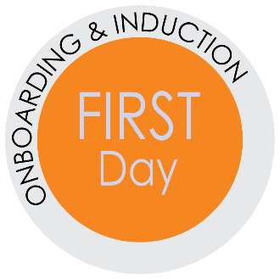
First Day Checklist and Itinerary
Best Practices for Direct Supervisors when Onboarding New Employees.
Onboarding assists organizations in ensuring that new employees are up and functioning
as soon as possible. If the onboarding process is implemented properly, it will enhance new employees’ transitions into the organization and help them become more engaged. – Workforce Management, 2009a
Practice | Tasks
Enthusiastically WELCOME the new employee | Prepare work area with a clean desk and chair, stock the necessary supplies, remove non-essential items and organize the space
 | Set-up computer with software and all needed components
 | Set-up phone including their name
 | Have a name plate available for their office area
 | Provide a copy of the UF employee handbook
Show that you are prepared for them | Schedule orientation meetings with appropriate team members and staff
 | Prepare a detailed Onboarding plan (see templates)
 | Have Email account ready
 | Provide a welcome card or small gift
Connect the new employee to team members, HR Rep, and his/her buddy | Review the Buddy System Process
 | Select and notify a buddy
 | Arrange a meet with the buddy
 | Arrange a meeting with the HR Rep for new employee conversations
 | Schedule one-on-one “Meet the Team” meetings
 | Review the department’s organizational chart
 | Explain each team member’s role and responsibilities (who serves as lead, who is the “go-to person for different questions, etc.)
 | Give a tour of building, lunch area, restrooms (Supervisor or Buddy)
 | Have lunch together with Supervisor and/or Buddy
Direct supervisor explains the expectations and onboarding plan | Meet with the new hire to discuss job description, expectations, policies, and the UF employee handbook
 | Provide opportunities for questions about the expectations
 | Review onboarding plan
 | Set milestones and specific deadlines for the first week
 | Provide time to explore benefits using ALEX

Onboarding is the process of integrating and acculturating new employees into the organization
and providing them with tools, resources and knowledge to become successful and productive.
– Getting On Board, A Model for Integrating and Engaging New Employees, Partnership for Public Service, 2008
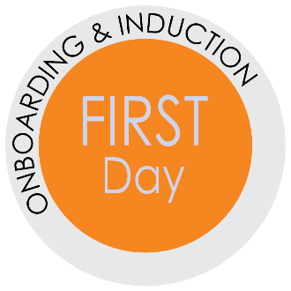

First Day Sample Itinerary
8:00-9:00 a.m.
Meet with the direct supervisor (provide a Room #)
- Building tour (could tour with their buddy)
  - Work areas and additional rooms to use
  - Workstation and email log-in
  - Copier/FAX/Scanner review
  - Library, supply closet, supply requests and other work spaces
  - Service drive pass (if applicable)
  - Bathroom, employee lounge, mailroom
  - Refrigerator, microwave, water and coffee
- Policies (Supervisor)
  - Establish hours, including lunch and attendance expectations
  - Email policy
  - Telephone usage (How to & logging long distance)
  - Professional dress and conduct
- Miscellaneous
  - Department and HR policies
  - Discuss Meetings:
    - Weekly check-in with direct supervisor (date and time)
    - Biweekly team meetings (date and time)
    - Monthly all-employee department meetings (date and time)
  - Cubby name plate and UF name tag
9:00-10:00 a.m.
Meet with HR Rep (Dean’s/VP’s Office)
- If the hiring process is not completely finished, complete the final paperwork with (HR Rep name).
The employee may need:
  - Copy of driver’s license and SSN card
  - Complete loyalty oath form
- GatorLink login and password for computer and email access (36-hours after the UFID is created)
- Provide the Phone access and password information
- Security to the building (mention any special security for your area), keys and parking tips
10:00 a.m. to 12:00 p.m.
- Order your parking decal online from Transportation and Parking. They can do this the day after their first day as long as the hire has been processed into the system
- Go to the UF Bookstore to get your Gator1 ID, HSC employees do this at the HSC Gator-1 Annex
- Get settled into your workspace
- You’ll have meetings with all of your teammates over the next two weeks, so check out their bios. (include hyperlink)
12:00-1:30 p.m.
Have lunch with direct supervisor and/or your buddy

1:30-4:00 p.m.
Orientation to the calendar, HR website and myTraining
- Get your calendar ready for unit business. Share full calendar details and request full
calendar details for all members of unit. Please include: (List with name and address)
- Become familiar with how to enter time and/or leave in myUFL. Here is a video tutorial to use.
- Explore your benefits using ALEX
- Review the unit’s website and the HR website for the “Just In time Toolkits” in the “Learn & Grow” section.
- Tour the myTraining system:
  - Log in to myUFL > Main Menu > My Self Service > Training and Development > myTraining Enrollment or http://mytraining.hr.ufl.edu.
  - Take the myTraining system tour
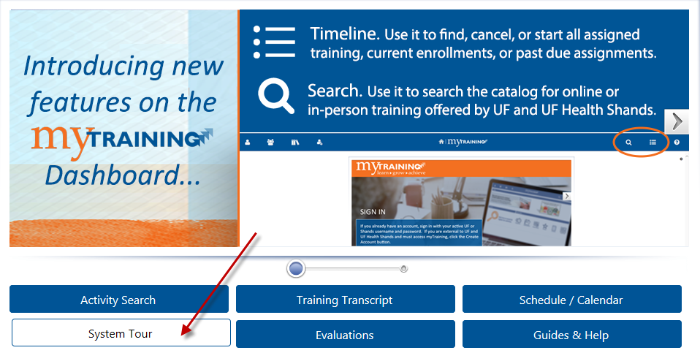
  - Start one of the required trainings

4:00-5:00 p.m.
Meet with supervisor
- Review job duties, discuss first project and upcoming projects
- Discuss the UF employee handbook, encourage them to read it and ask questions
- Set goals for the first week with specific deadlines
- Discuss quality work expectations

