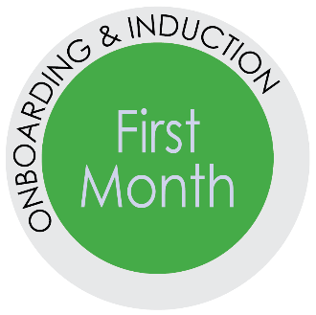
First Month Checklist
Best Practices for Direct Supervisors when Onboarding New Employees.
According to the Society for Human Resource Management (SHRM), studies
indicate that employee engagement is partially influenced by the new employee’s
handling of the job during the first 30-90 days of employment.
– Fyock, 2009
Practice | Tasks
Align training with  job-related tasks | Start new hire with required trainings, such as Maintaining a Safe and Respectful Campus, HIPAA, and Hospitality Training for Health Science Center employees
 | Prioritize training for work-related system(s) access
 | Intersperse training with job-related tasks
 | Spread the training out over several weeks
Provide clear expectations and regular feedback on  the expectations | Establish weekly check-in meetings to discuss performance and allow opportunities for feedback
 | Set short-term goals with specific deadlines and discuss completion of goals in the weekly check-in
 | Determine that the new employee understands the department organizational structure, has the training necessary to complete their work, and are clear on work expectations
 | Meet with your new hire for daily conversations during the first week and be available to provide direction and examples of your expectations
 | Review your department’s strategic plan and the team’s role in fulfilling it
 | Tell your new hire specifically how well they have done and include specific ways to improve their work
 | Use the “OH NO! Do I Have to Have that Conversation” tool to have a conversation about success points and areas to grow
Build relationships  for success | Check-in on the progress of the one-on-one “Meet the Team” meetings
 | Set-up time for the new hire to meet senior leaders
 | Check-in with the new hire’s buddy
Benefit selection | Inquire about the new hire’s progress with ALEX or meeting with a benefits counselor
 | Encourage them to select their retirement plan and health care options
Large amounts of time and money are invested in searching for and
recruiting new employees. Organizations lose when the new employee is disenfranchised at the
beginning of his or her employment. Productivity and positive engagement can be affected.

Questions for the Weekly Check-in Meeting
Develop a meaningful agenda so your weekly meetings stay on task. Have your new hire provide:
- Accomplishments for the week
- Successes
- Challenges
- Questions
Questions to consider during the regular check-in meetings and at the end of the first month.
- Do you have the resources and tools necessary to complete your University, department, and
work-related training?
- Tell me how the training is going? Any questions about the training?
- What questions do you have for me?
- What do you need from me that you are not getting?
- What is working well?
- What is not working well?
  - What ideas do you have to resolve your issue(s)?
  - How can I help you resolve your issue(s)?
- Have a conversation to understand the new hire’s experience with their job. Be clear with your expectations.
  - I see you are making good progress in these areas. What are areas where you feel successful?
  - Are there in areas where you feel like you need special help? Any areas that have a steeper learner curve or are more challenging?
  - Here are some specific areas that could be improved and this is what I am looking for. Any questions about what I am looking for?
- Are you getting to know your team members?
- How are things going with your buddy?
- Do you have any question about the department’s organizational structure?
- Any questions about the expectations regarding topics like attendance, dress code, computer use, etc.?
- Any questions about the UF employee handbook?
- Any questions about your benefits package?
If things are starting to go off track with the new hire’s performance, behavior or attendance, review the “OH NO! Do I have to have THAT Conversation” in the
First Month Resources.

