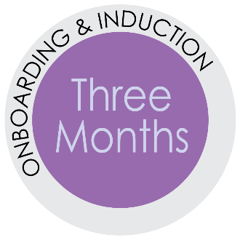
Three Month Checklist
Best Practices for Direct Supervisors when Onboarding New Employees.
“. . . the biggest reason why people fail or underperform has to do with the culture and
politics of the organization . . . so I focus a lot on basically three things:
how we are going to help this person adapt to the new culture;
how are we going to connect them to the right people and
help them form the right relationships; and
how are we going to be sure that we really align expectations
in every direction so that they’re set up for success…”
– Michael Watkins, author of “The First 90 Days”
Practice | Tasks
Provide clear expectations and regular feedback on  the expectations | Be an active supervisor; intervene early with any attendance, performance, or conduct concerns; clarify expectations often; provide feedback weekly
 | Facilitate goal setting and assign training as needed
 | Evaluate how the employee is progressing through probation – Are they a Yes, No or Maybe? (see the Three Month Probationary Check-in)
 | Use the “OH NO! Do I Have to Have that Conversation” guide and check-in questions on page 2 to engage in a conversation about success points and areas to grow with your new hire
 | Explain and provide examples of what excellent work looks like from your perspective
 | Tell your new hire specifically how well they have done and include specific ways to improve their work
 | Inquire about any duties the new hire is unclear on
Build relationships for success | Arrange for new hire to meet division personnel
 | Provide new hire with a buddy
 | Check-in with the new hire’s buddy
 | Inquire about how the new hire is feeling about his/her integration into the team

A work culture is defined by the worst behavior it is willing to tolerate.

Questions for the Weekly Check-in Meeting
Develop a meaningful agenda so your weekly meetings stay on task. Have your new hire provide:
- Accomplishments for the week
- Successes
- Challenges
- Questions
Questions to consider during the regular check-in meetings and at the conclusion of 90 days.
- Do you still have the resources necessary to complete your University, department, and
work-related training?
- What is working well?
- What is not working well?
  - What ideas do you have to resolve your issue(s)?
  - How can I help you resolve your issue(s)?
- Is there any support you need from me? Am I providing the right level of feedback for you or do you need more or less from me?
- Have a conversation to understand the new hire’s experience with their job. Be clear with your expectations.
  - I see you are making good progress in these areas. What are areas where you feel successful?
  - Are there in areas where you feel like you need special help? Any areas that have a steeper learner curve or are more challenging?
  - Here are some specific areas that could be improved and this is what I am looking for. Any questions about what I am looking for?
- Do you feel that your experience as a team member is a positive one? Are you feeling included as part of the team?
- How are things going with your buddy?
- Do you have feel you are adapting well to our culture and standards?
- What would you like to learn more about?
If things are starting to go off track with the new hire’s performance, behavior or attendance, review the “OH NO! Do I have to have THAT Conversation” in the
First Month Resources.

