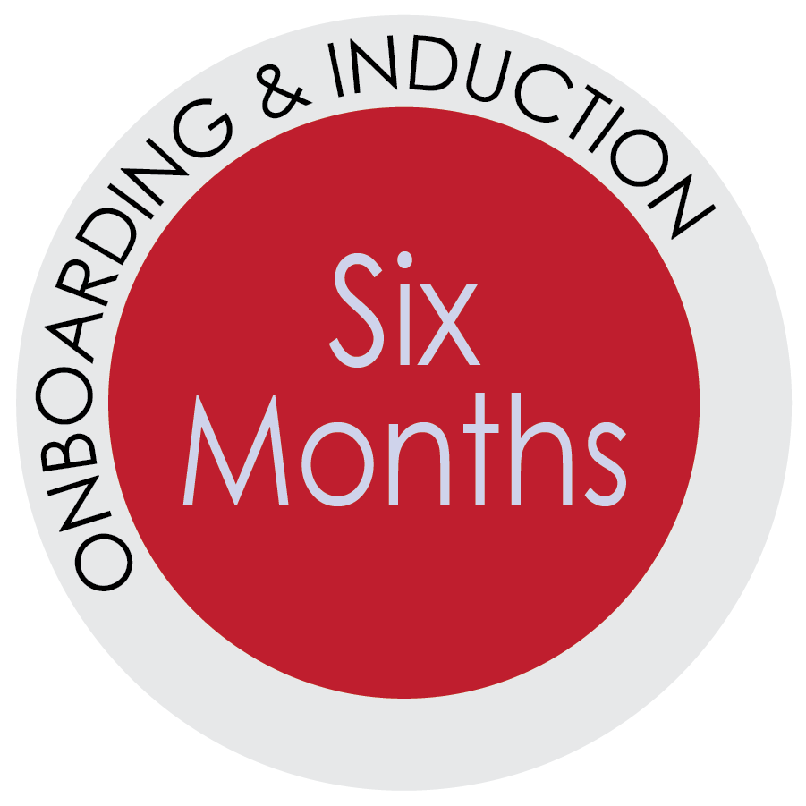
Six Month and Beyond

The 6-month mark is a major milestone.
Don’t let it slip by without acknowledging it as such . . . and take this as an opportunity to discuss with your new hire your thoughts on his or her performance.
Part of employee retention relies on the employee seeing a future with the employer.
Be active in helping your new hire understand what lies ahead.
Reminder:
If an employee’s performance or conduct is dreadfully poor (and they have not positively responded to early intervention), they should be released from employment far ahead of the 6-month mark.
Hopefully, you have been actively providing feedback up to this point, so the employee knows exactly how they are doing. The employee should know what you think they are doing well and where they have additional progress to make.
No matter where the new employee lies on the scale of good to superstar, passing the 6-month threshold is something to celebrate.

As the direct supervisor, consider structuring the 6-month performance
conversation by selecting appropriate and relevant topics and questions
in three steps:
- STEP 1: General questions and clarification
- STEP 2: Key employee attributes
- STEP 3: In-depth discussion of higher-level skills
Before you start, first acknowledge the successful completion of the probationary period. Even if an employee is doing a great job
(and you’ve been telling them), this is still a milestone to acknowledge.

The topics and questions in this resource can also be used in the 9-month and all performance conversations going forward. This is not an all-inclusive list. However, it is an excellent way to have meaningful conversations with your employee(s).

Step 1: Start with General Questions and Clarification
Select the questions that are relevant to the new hire’s performance and share them with your employee prior the performance check-in meeting. Both the manager and the employee should reflect on the categories and the questions that the direct supervisor selects.
Select 1-2 Key Employee Attribute that are relevant for the employee for discussion.

RECOMMEDED TOPICS
- Accomplishments
- What are the new hire’s major accomplishments during the first 6-months of employment?
- What goals were accomplished during this time period?

- Strengths and Opportunities for Growth
- What are the employee’s strengths?
- What are the employee’s areas for growth?

- Clarification
- What questions or concerns do you have about your job responsibilities?
- Any questions about departmental or university policies or procedures that regularly
apply to your job?

OPTIONAL TOPICS
- Quantity of Work
- Is the employee completing assigned work within an acceptable timeframe?

- Quality of Work
- Is the employee’s work well executed, thorough, effective, and accurate?

Step 2: Consider Key Employee Attributes
Select the questions that are relevant to the new hire’s performance and share them with your employee prior the performance check-in meeting. Both the manager and the employee should reflect on the categories and the questions that the direct supervisor selects.
Select 1-2 Key Employee Attribute that are relevant for the employee for discussion.
- Knowledge of the Job
- Is the employee knowledgeable and able to demonstrate their knowledge in all phases of the assigned work (considering the short tenure)?

- Relations with Supervisor
- Is the employee responsive to supervisory directions & comments?
- Does the employee seek guidance from supervisors and apply the feedback provided?

- Relations with Co-Workers and Business Partners
- Does the employee get along with others?
- Consider the employee’s tact, communication skills, and effectiveness in dealing with co-workers, subordinates, and customers, how well do they do?

- Attendance and Reliability
- Has the employee adopted acceptable attendance practices?
- Does the employee complete tasks on time and appropriately manage their meeting and task schedule?

- Initiative, Creativity, Problem Solving
- What questions or concerns do you have about your job responsibilities?
- Any questions about departmental or university policies or procedures that regularly apply to your job?

- Capacity to Develop
- Does the employee demonstrate an ability and willingness to learn new skills, accept additional responsibilities?

Step 3: More In-depth Discussion of Higher-Level Skills (as applicable)
Your employee may be ready for a deeper discussion of high-level skills. Select the topics or soft skills that are relevant to the new hire’s key functions and primary duties. Share them with your employee prior the performance check-in meeting. Both the manager and the employee should reflect on the categories and the questions that the direct supervisor selects.
Select 1-2 Higher-Level Skills that are relevant for the employee for discussion.
- Possesses Functional Knowledge and Skills:
- Is the employee viewed as possessing high functional knowledge and skills? Where does the employee have strengths and weaknesses?
- What additional training or education would best benefit the employee in being successful in their role?
- How does the employee demonstrate expertise in skill and knowledge within areas relevant to their role or work group?
- How does the employee develop and contribute to best practices in discipline or specialty area for the work group?

- Building Trust
- Does the employee behave and express oneself in an open and honest manner?
- Does the employee effectively follow through on all assignments and commitments, completing them in a timely and reliable manner?
- Is the employee able to prioritize tasks, meet deadlines, and appropriate handle sensitive information?
- Demonstrates commitment to UF’s strategic/departmental goals, initiatives, policies, and procedures through communication and actions?

- Effectively Communicating
- How well does the employee listen to others, ask questions for clarification, and ensure messages or tasks are understood?
- Does the employee demonstrate an ability to influence others by clearly, concisely, and professionally communicating with others?
- Does the employee have the ability to tailor communication styles to the needs of each situation and audience?
- Does the employee assure relevant stakeholders are made aware of the status of important tasks or assignments?

- Collaborative/Customer Service Focus
- Does the employee treat everyone, with dignity, respect and fairness? Does the employee promote respect among all team members, “customers,” and business partners?
- Is the employee easy to approach and helpful?
- Does the employee carefully listens to and consider ideas from others, even when different from their own?
- Does the employee encourage teamwork? Is the employee eager to collaborate with others and pitch in to help the team succeed?

- Solving Problems/Taking Initiative
- Is the employee able to appropriately handle stressful and difficult situations?
- Does the employee makes informed decisions (based on available policies, procedures, and guidance)?
- Does the employee actively seeks out ways on own to improve outcomes, processes, or measurements?
- Does the employee assist or work with other employees in diagnosing (finding the root cause of) problems and recognizing issues, inefficiencies, or problems?

- Delivering Results
- Does the employee meet or exceed performance in tasks and goals?
- Does the employee effectively manage time and prioritize? Is the employee able to re-prioritize, when needed? Does the employee appropriately or effectively delegate, if that is an option?
- Is the employee receptive to (and able to implement) suggestions for improvement? Does the employee actively solicit feedback? Is the employee able to self-identify ways to improve?
- If the employee is in a leadership role, does the employee hold direct reports accountable for producing quality, timely results? Does the employee help others maintain focus and overcome obstacles?

