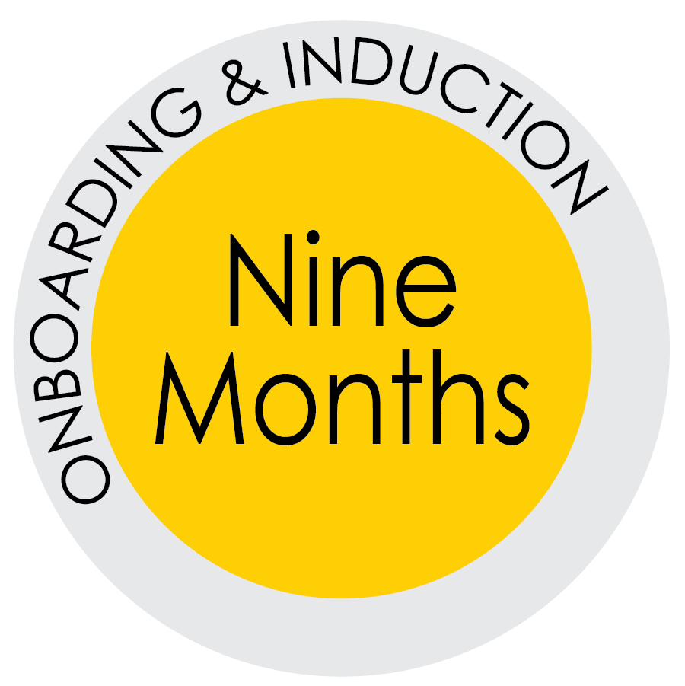
Nine Month: Promoting to Engagement and Retention

We’ve trained them, encouraged good behavior and attitudes, and coached the
new hires on their job duties. “Now, how can you keep your stellar employees?”

Are your employees engaged? Are you sure?
Employee engagement matters! Why?
- Engaged employees are 66% more likely to always try their hardest at work.
- Engaged employees are 83% likely or very likely to stay late at work if something needs to be done after the normal workday ends.
- Engaged employees are 74% more likely to do something that is good for your company even if it is not expected of them.
- Engaged employees are also 50% more likely to make recommendations for improvements.
Source: https://www.ellucian.com/White-Papers/Cornerstone-Empowering-Employees/

How would they answer these questions?
- Do you know what is expected of you at work?
- Do you have the materials and equipment you need
to do your job?
- At work, do you have the opportunity to do what you
do best every day?
- In the last seven days, have you received recognition
or praise for doing a good job?
- Does your supervisor, or someone else at work, seem
to care about you as a person?
- Is there someone at work that encourages your development?
- Does the mission of your unit (department or college) make you feel like your job is important?
- Are your fellow employees committed to doing
quality work?
- Do you have a best friend at work?
- Has someone at work talked to you about your progress?
- Have you had opportunities to learn and grow?
- Do your opinions seem to count?

Ask your employees:
What do we need to do to keep you engaged, challenged,
and a happy member of our team?

