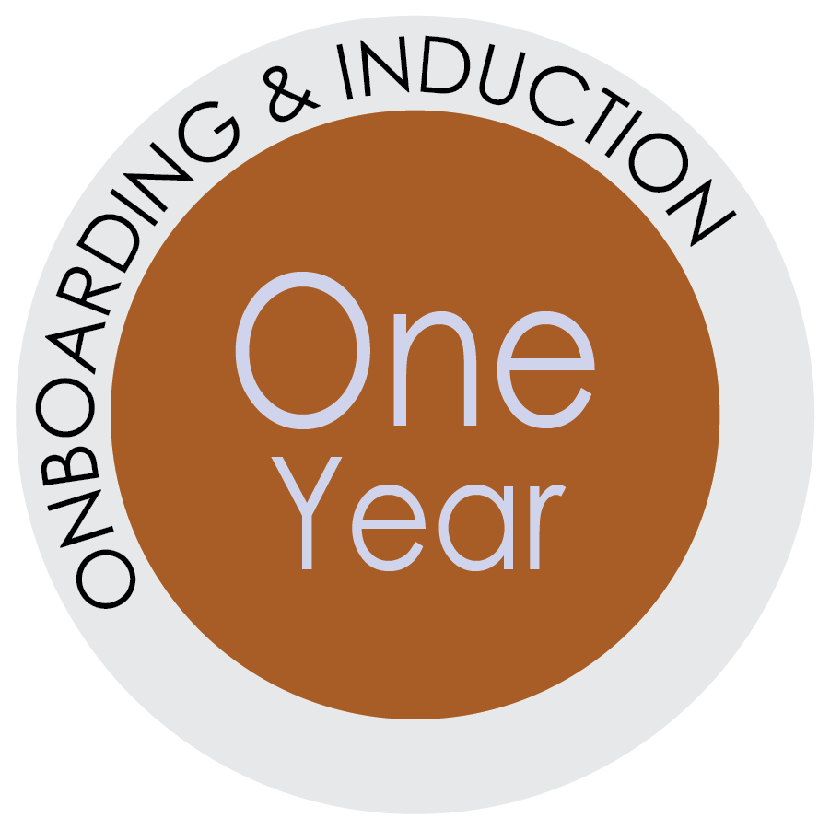
First Year Anniversary
Your new employee isn’t so new anymore. The one-year mark is quickly approaching and it is time to recognize the anniversary and discuss performance, retention, and engagement.
What are you planning to do to acknowledge this important anniversary?
Hopefully, it has been a great year for your new hire. If you followed the onboarding plan,
you have been providing regular and timely feedback and you had a more formal
performance discussion at the six-month mark.
Naturally, part of the 1-year conversation needs to be about performance, conduct
and attendance. But you should also devote time to ensuring the new hire is engaged
and feels like they have a future both with UF and in this particular position.
If they are doing a good job, you want them to stay put, right?

No Surprises…Schedule Ahead
Plan ahead and tell your new hire there will be a 1-year conversation and ask them to reflect upon their first year—what is going well, what isn’t. This way they know what to expect and what you want them to be thinking about—whether it is goals, training, what they like about the job, what frustrates them, areas where they realize they need to improve, areas where they think they are excelling, etc.
Give them some food for thought so they can come to the meeting with ideas to share. If you are providing a written appraisal, provide it to the employee in advance, so they can review it in private and take some time to process what you’ve written. Consider asking the employee to assess themselves using the same form or topics that you will use in assessing them.

Start by Listening
This conversation should be more than just you telling the employee what you think of them.
This is also an opportunity for you to learn more about what your employee thinks of the job and what they need to feel challenged, be successful, and remain engaged.
- Do they want more responsibilities?
- Is the workload reasonable?
- What ambitions do they have and how can you help them advance their
skills and knowledge?
“What do I need to do to keep you here and keep you happy?”

Set a Tone
You can respond to the employee’s perspective by following up with your own. Keep in mind, the conversation needs to be honest…so, forego the sugar-coating. Be respectful, but also be honest and constructive. Start by laying out your top compliments first—identifying the employee’s strengths and achievements. Be specific. “You’re doing a great job,” while nice to hear is not actually terribly helpful.
Spend some times identifying your top concerns and areas for growth and improvement. Be specific. “I need you to communicate better,” may be a true statement, but you need to follow it up with specific and actionable examples of what the is employee is doing now that needs to stop and what the employee needs to start doing instead.
Talk about the path forward and where you would like to see the employee. Even though frank conversations are often difficult, you are not doing any employee a favor by not sharing the full picture—the good, the bad, and the aspirational.
Set Goals & Expectations
Whether you have an okay employee or a superstar, you want to get them thinking about what they can accomplish in the future. Consider setting SMART goals. These are goals that are goals designed to be: Specific, Measurable, Attainable/Achievable, Relevant, Time-bound. Instead of vague goals (“work harder” or “be more organized”), SMART goals are intended to add clarity and specificity to what the goal is and what success looks like. For example, a SMART goal is: Increase Customer Satisfaction Score to 90% by December 31 rather than Provide Better Customer Service.
Need Help Articulating Goals or Preparing for a Touch 1-year Conversation? Contact UFHR - Employee Relations.
Be sure to offer resources. Good goals should provide successes rather than failures if the new hire works at them diligently.
Embrace your Coaching Duties
In reality, we understand that most supervisors have their own workload. It can be a struggle to
find time to devote to actual supervising. But, that’s part of the job—and not a trivial part.
Embrace your role as a coach. Coaching—which requires positive and negative feedback as well
as encouragement—is a good way to think of these duties. Part of your responsibilities is to help your employees hone the skills they need to be successful in their positions.
Express Gratitude
Your new employee has now devoted a year of their professional life to your team. Even if they have room to improve, this is still worth recognizing and appreciating. Be sure to end the conversation by reiterating the top action-items you want to see the employee taking in the year ahead.
Continue to provide at least bi-weekly feedback that is timely and specific with words of praise, recognition, and correction, as needed, throughout the year.

CREATE: Sample/template emails for the leader to customize

