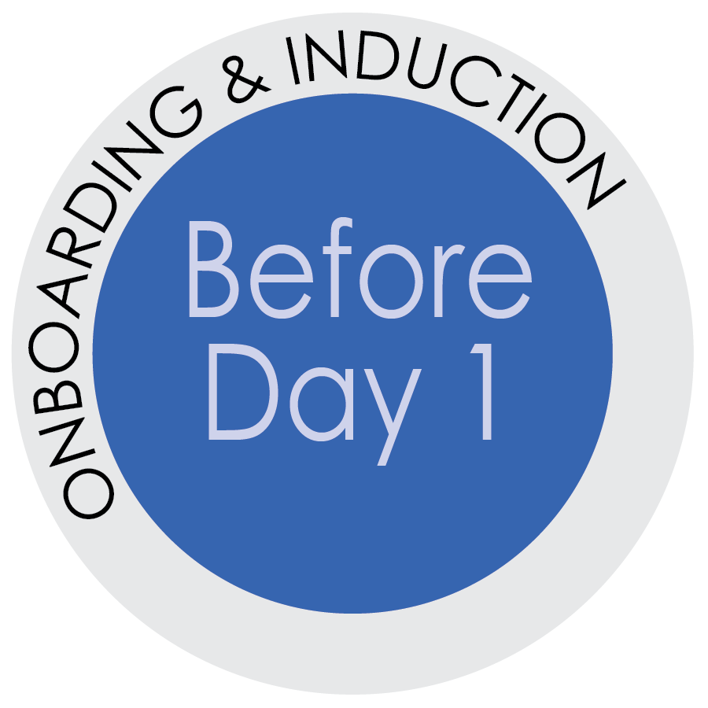
First Impressions Matter!
The first 30-days matter! Why?
New hires decide during their early days on the job if they want to stay
based on whether they feel connected or disconnected to the organization,
their supervisor and co-workers, and the job itself.

First impressions are lasting and can be hard to overcome, so help your new hire’s first impression be about their fabulous new job and the great people they will work with. Provide ways for them to feel connected to their work and to their new team.
A key strategy is to organize training so it is spread out across the first 3-4 months. This way your new employee will not only assimilate into your team but they may also retain what they are learning. There is often an enormous amount of training for new hires to complete and cramming multiple trainings into a short amount of time is ineffectual and mind-numbing. In other words, good on-boarding isn’t a “one and done” deal. It is a process and each step helps acclimate your new employee to their position, your job expectations, and their place among the team.

With careful planning you can divide the training into
small manageable time slots, embedded with job specific tasks,
job shadowing and relationship-building during the first few months.

Weaving in job specific tasks and job shadowing with the training
will connect the new hire to their job and
help the supervisor assess the new hire’s skills and potential gaps.

How does the Supervisor Prioritize Training?
IMPORTANT: Evaluate which trainings are critical to Key Job Duties and indicate these in the training plan.
Group the trainings into at least three areas:
- Top priority – to be taken in the first month. The new hire must be able to do their daily key job duties with appropriate roles. For some job positions with numerous roles, additional grouping of the training may be needed. For example: Group the PCard training together for one day, group the Accounts Payable and Receivable courses together etc.
- Medium priority – needed for job duties but the tasks are not daily (budget, end of semester tasks etc.), leave these trainings for the second or third month depending on the time of year.
- Low priority – training to be taken in the third or fourth month
Consider pre-requisites and trainings with several parts and organize them logically.
TIP: Before Day 1 create calendar invites for the new hire to meet team members, department staff and faculty, and upper management.

Week 1 Schedule for combining training, job-specific tasks and meeting the team
Day 1 for your new hire
- Use the First Day check list and Itinerary resource to make your Day 1 welcome plan.
- Be sure to assign a buddy before Day 1, see the resource “Assigning a Buddy”
- Throughout the week have the new hire meet 1-2 team members to discuss projects, roles and how their jobs overlap
- Arrange for the buddy and team members to have lunch with the new hire during the week
Day 2 – The new hire will:
Prepare for Training
Before your new hire’s first day, confirm that they have an account setup in myUFL and myTraining.
Complete a security role review for the new position with your HR Rep or DSA.

(It is helpful to identify the security roles before the previous employee leaves the position or keeping a security role list by job position to speed up the process of creating a training plan.)

- At the start of their workday, complete 1 top training priority such as Maintaining a Safe & Respectful Campus
- By mid-shift (early afternoon for a first shift employee), complete 1 role specific training (i.e., PCard)
- Meet some of their campus stakeholders with your buddy
Day 3 – The new hire will:
- At the start of their workday, complete 1 top training priority, such as HIPAA
- By mid-shift, complete 1 or 2 role specific training
Day 4 and 5 – The new hire will:
- At the start of their workday, complete 1 top training priority
- Meet with a team member (or buddy) who can share institutional knowledge and specific position knowledge
- Work on a job specific tasks based on the training completed
or job shadow with someone doing the work
- By mid-shift, complete 1 role specific training
TIP: Be sure to check-in and make sure the new hire has what they need to complete their work.
As your new hire moves into week 2, consider:
- What tasks will reinforce the training they have completed?
- Has the new hire completed required trainings such as Protecting SSNs, Maintaining a Safe and Respectful Campus, and top priority trainings for key job duties?
- Is there software training they can do with their buddy or a department expert?
- What extended stakeholders can the new hire meet to better understand the needs of their job?
- Will they be participating in their first team meeting? If so, provide context for them.

In weeks 3 and 4, consider:
- Are there small tasks or projects where the new hire can be responsible for a subset of the work?
- What tasks will reinforce the training they have completed?
- Have they explored the UF systems needed for their job with their buddy or another co-worker?
- Is a team or department member available to host the new hire on a day (or partial day) of job shadowing (consider specific skills or tasks the host does well that you would want the new hire to
learn and copy)
- How are they progressing with the role access training?
- Have they meet senior leaders in your areas?

Be sure to check-in regularly to get feedback from the new hire
as you review their work. How are they feeling? What questions have come up? What challenges are they identifying? Also provide useful feedback and
do not put off having any difficult conversations, if it is clear they are needed.
(For guidance on difficult conversations, see First Month, “OH NO, do I have to have THAT conversation?!”)

