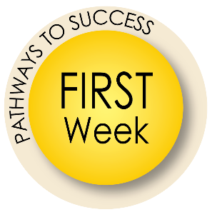
For Department Chair and Administrative Professional Use
Sample Itinerary
Click here to see a Sample First Week Itinerary for Faculty.

Checklist for First Week
- Provide keys to faculty office/lab/building
- Provide faculty with office phone numbers and business cards
- Attend New Faculty Orientation if starting in August
- Discuss how to order books, pull roster reports, and access Canvas
- Go over expectations for office hours, business hours, and faculty meeting attendance as well as other regular meetings the faculty will be expected to attend
- Discuss departmental procedures
- Go over Training Prioritization (see below) – NOTE: determine if there is any concern within your department about new Faculty taking training before they are officially on payroll
- At the conclusion of EACH day of the first week, make time to check in to see if the
faculty member has any questions or concerns
Reminder: Prepare for Training
Before your new faculty’s first day, confirm that they have an account setup in myUFL and myTraining.
Complete a security role review for the new position with your HR rep or DSA.
(It is helpful to identify the security roles before the previous faculty leaves the position or keep a security role list by job position to speed up the process of creating a training plan.)

Create a Prioritization Plan for Training
Ensure that the faculty member has the right role and permission to access myTraining. Required training pertaining to their position must be done as soon as possible (Compliance and Harassment Prevention). Other trainings can be spread out across the first 3-4 months. This way your new faculty will not only assimilate into your department but they may also retain what they are learning. There is often an enormous amount of training for new faculty to complete and cramming multiple trainings into a short amount of time is ineffective and mind-numbing. In other words, best practices in faculty orientations is a process and each step helps acclimate your new faculty to their position, your job expectations, and their place within the department. Consider pre-requisites and trainings with several parts and organize them logically.
IMPORTANT: Evaluate which trainings are critical to Key Job Duties and indicate these in the training plan.
Group the trainings into at least three areas:
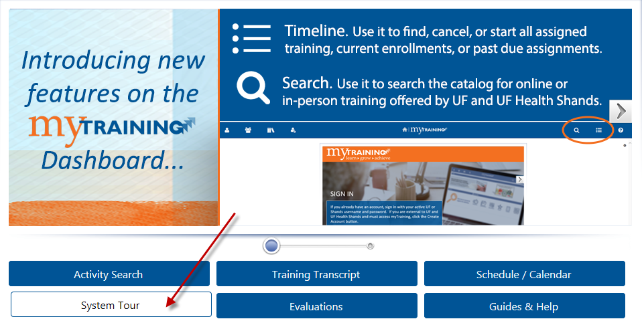
- Top priority – to be completed within the first month. The new faculty must be able to do their daily key job duties with appropriate security roles.
- Medium priority – needed for job duties but the tasks are not daily responsibilities (budget, end-of-semester tasks, etc.). Leave those trainings for the second or third month depending on the time of year.
- Low priority – to be completed within the third or fourth month.

